Hamster Operation and Assembly Manual

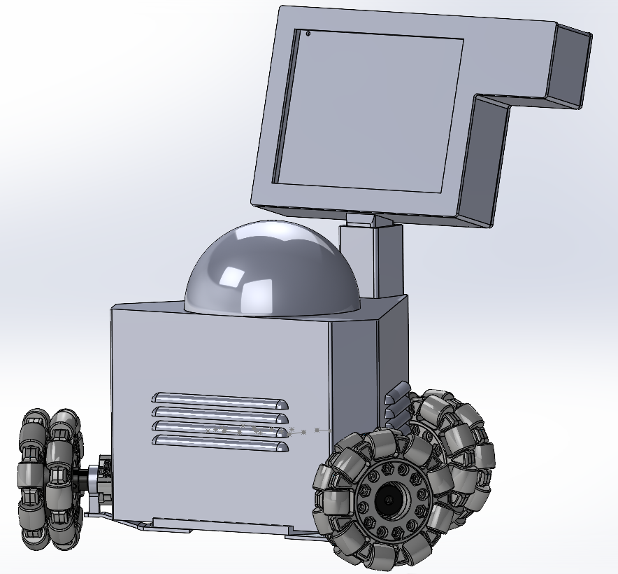

**Assembly/Disassembly**

The hamster will come fully pre-assembled, but user should verify that all screws are properly tightened down, including set screws for the wheels.

**Operation**

Ensure that Hamster is always operated on a clean, smooth and level surface, failure to do so may cause wheels to break and fall apart.

Do not exceed 20lbs of added weight to Hamster as it may cause components to bend or break and cause the motors to burn out.

**Maintenance Instructions**

Before each use ensure that the battery is properly charged and the set screws properly fastened.

When charging battery ensure that it does not stay on charger for more than 3 hours to prevent over charging.

**Trouble Shooting**

If the computer is not responding to inputs turn the device off for 15 seconds and turn it back on.

If the device does not power on check battery level.

If the device is powered on but the screen fails to output an image, check the HDMI connection on the right side of the screen.